- Battery installation method.
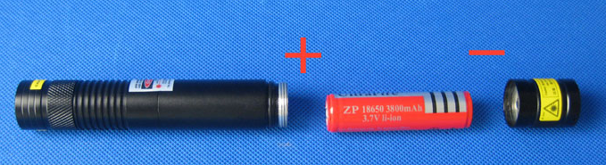
- Security warning
- Do not look at the laser directly.
- Do not use laser irradiation of others.
- Do not use laser irradiation the objects which is easy to reflect light.
- Do not let a minor child touch laser pointer.

Charge Description：
When charging the red light is on, after charging full the signal light is green.
Charging time reference:
- 18650 battery: About 6 hours;

Lithium battery using common knowledge:
- Do not over charging, over discharge, or whatever the lithium battery once will be scrapped (remember not to reduce the service life, was scrapped)
- Do not run out the battery power, when you find that the lights dimmed you need to charge. (Do not charge too long time, just full is the best ;)
- Beware of the battery is shorted, because the battery is not set short-circuit protection can result in excessive heat, or explosion
- Do not throw batteries into fire, otherwise it will explode.

安全警告
- レザーを直視ないでください。
- 他人にレザー照射をしないでください。
- 反射し易いものにレザー照射をしないでください。
- 未成年の子供をレーザーポインターに接触させないでください。

